Curriculum Vitae 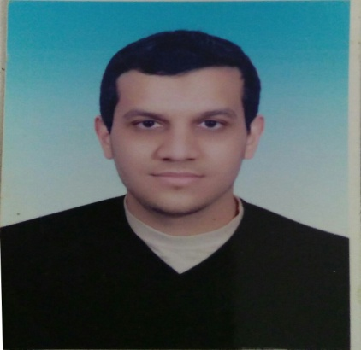
Personal data:
Name : Ramy Mostafa AbdElGawad.
Birth date : October 1st, 1988.
Gender : Male.
Place of birth : Assiut, Egypt.
Nationality : Egyptian.
Marital status : single
Military status : Exempted.
Address: , Assiut, Egypt.
Telephone : - Home (+20)882327498
- Mobile (+20)1019958281
E-mail : Ramy mostafa888@yahoo.com
Ramy888@aun.edu.eg

Present occupation:
- Assistant Lecturer - Department of Anesthesiology, Intensive Care, Faculty of Medicine, Assiut University Hospitals – Assiut - Egypt.
- Part of Cardiac anesthesia team since 2016.
  - Registered at the Egyptian Ministry of Health. license no. 238426
Academic Record:

March 2017 | Master Degree in Anesthesia from Assiut University signed up with "Very Good"
Oct. 2014 | First part of master degree in Anesthesia, ICU, and Pain management signed up with "Very Good" studying anatomy, physiology, pharmacology, physics & internal medicine.
Sept. 2011 | M.B.B.Ch. degree in medicine & surgery from Assiut University, Faculty of medicine, signed up "Excellence with honor, ranked 28nd among the 610 medical students in my college.
2005 | Graduated from High School with score 99.5 %
Professional Record:

March 27th 2017 – till now  September 1nd, 2015 – March 26th 2017 | Assistant Lecturer, Department of Anesthesia,  Assiut University Hospitals, Assiut, Egypt.  Demonstrator, Department of Anesthesia, Assiut University Hospitals, Assiut, Egypt.  (Residency training continues)
March 7th, 2013 – August 31st, 2015 | Resident of Anesthesia, Assiut University Hospitals, Assiut, Egypt.
March 1st, 2012– February 28th, 2013 | House officer at Assiut University Hospitals, Assiut, Egypt.

Languages:
- Arabic: Mother tongue.
- English: fluent.
- Dutch: little.
Personal Skills:
- Self-learning
- Hard working
- Team work
- Work under stress
Computer skills:
- Sufficient computer skills

Summary of Duties:
- March 7th,2013 – August 31st, 2015:
Working as a resident doctor in Assuit university hospital including:
- Attending 6 operative lists per week covering all anaesthetic specialities and subspecialties, attending the preoperative surgical fitness clinic once per week.
- Attending a casualty roaster every two days supervised by an assistant lecturer.
The operative lists achieved by the whole anaesthetic team in our hospital per week include:
- Plastic surgery (average of 40 cases per week in the lists)
- Vascular surgery (average of 15-20 cases per week in the lists)
- Neurosurgery (average of 15-20 cases per week in the lists)
- ENT and Ophthalmic surgery (average of 40 cases per week in the lists)
- Pediatric general, orthopaedics & plastic surgeries (average of 35-40 cases per week)
- Orthopaedic surgery (average of 70 cases per week in the lists)
- Obstetrics and Gynaecological surgery (average of 15-20 cases per week in the lists)
- Genitourinary tract surgery (average of 50 cases per week in the lists)
- General Surgery (average of 50 cases per week in the lists)
- Endoscopic Surgery (average of 15-20 cases per week in the list
- Trauma Intensive care units including 10 beds. (Attending a casualty roaster every two days supervised by an assistant lecturer.)
- Attending two operative lists per week at anesthetic subspecialties.
Additional Duties (2013 – present):
- Teaching graduate students along the house officer- training program at our department.
- Helping in the achievement of goals of the residency program of training along the 3 years of residency

Hobbies:
- Watching movies.
- Playing & watching football.
- Traveling.
- Music.
- Reading.
- Chess.
- Social networking.
- Hanging out with friends.

Training courses:
2012 (During House officer training year) | *Surgical Suturing course.  *Ethical & law consideration in medical practice.  *CPR Course.  *Infection control course.
April 2015 | ACLS (Advanced Cardiovascular Life Support) provider course: Advanced professional course given by AHA (American Heart Association) with course certificate valid for 2 years.
August 2016 | *Infection control workshop.  *Evidence based medicine course.  *Medical reports workshop.
December 2016 | Safety in critical areas workshop.
January 2017 | Basic intensive care provider course endorsed by The European Society of Intensive Care Medicine.
April 2017 | I got registered to do my doctorate at Assiut university
August 2017 | ATLS (Advanced Trauma Life Support) provider course: Advanced professional course given by ACS (American College of Surgeons) with course certificate valid for 4 years & I got an instructor potential letter.

